**Internal Memory to External Memory**

; Initialize registers and data pointer

MOV R0, #05H ; Initialize counter to 5

MOV R1, #50H ; Initialize source address to 50H

MOV DPTR, #6000H ; Initialize destination address to 6000H

; Data transfer loop

L1:

MOV A, @R1 ; Move data from source address to accumulator

MOVX @DPTR, A ; Move data from accumulator to destination address

INC R1 ; Increment source address

INC DPTR ; Increment destination address (only lower byte)

DJNZ R0, L1 ; Decrement counter, jump to L1 if not zero

END

**Output**

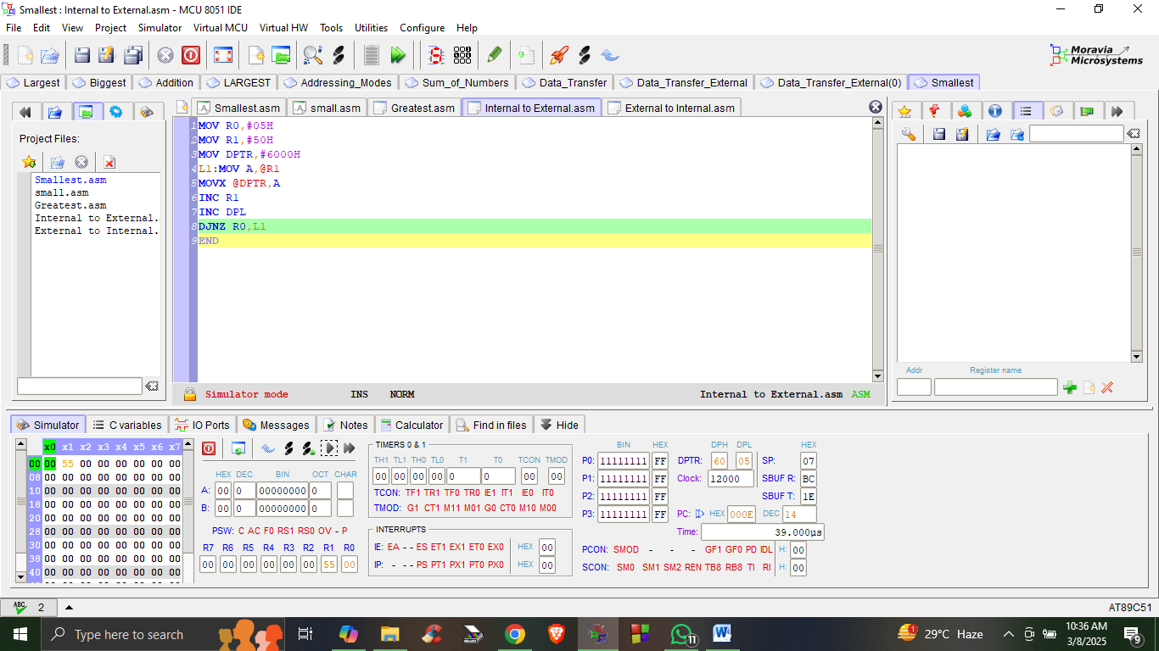

**External Memory to Internal Memory**

; Data Retrieval and Storage Program

ORG 0H ; Origin of the program

; Initialize registers and data pointer

MOV R0, #05H ; Initialize counter to 5 (number of data values to retrieve)

MOV DPTR, #5000H ; Initialize data pointer to 5000H (starting address of data)

MOV R1, #50H ; Initialize register R1 to 50H (initial value, not used in this program)

; Data retrieval and storage loop

L1:

MOVX A, @DPTR ; Move data from DPTR (memory location) to accumulator

MOV R2, A ; Move accumulator (data value) to R2 (storage register)

INC DPTR ; Increment data pointer to point to the next memory location

INC R1 ; Increment R1 (not used in this program, but could be used for other purposes)

DJNZ R0, L1 ; Decrement counter, jump to L1 if not zero (repeat loop until counter reaches 0)

END ; End of the program

**Output**

